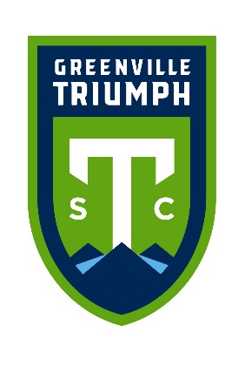

The Greenville Triumph Soccer Club is excited to announce the 2025 Read to Score Program brought to you by ScanSource! By taking part in the Read to Score Program, students will have the opportunity to earn one FREE ticket to the October 18, 2025, Greenville Triumph match at 7:00 PM, against South Georgia Tormenta FC. Each Triumph match takes place at Paladin Stadium on the campus of Furman University.

During the 2025-2026 school year between, September 9th and September 27th, students will be encouraged to complete a BINGO on their Triumph Read to Score Bingo Card. Bingo cards have tasks such as, “Read before you go to sleep” and “Read about your favorite sport”. Students’ hard work will culminate in receiving the opportunity to parade around the pitch during halftime of the 10/18 match!

**Guidelines:** We are asking students to complete one BINGO, horizontally, vertically, or diagonally between September 9th and September 27th. For each task that a student completes, we ask parents/guardians to initial in the completed square. We also ask that students show their teachers their progress at the end of each week that the program runs. Bingo cards have a space to initial the Bingo squares for teachers to initial. On the Triumph website, teachers can find short encouragement videos from Triumph players, wishing readers good luck during the program and giving facts about their favorite reading experiences.

**Materials:** The materials below can be found on the Greenville Triumph website at <https://www.greenvilletriumph.com/programs/read-to-score-program>

* A copy of the teacher/media specialist/librarian program materials
* NEW! An informational letter to inform parents/guardians of the program combined with the Bingo Card for students to fill out as they complete the program
* NEW! Teacher challenge! Top performing schools per category of enrollment earn staff Sky Club access with free snacks and beverages during the match!
* A congratulations letter for students who complete the Read to Score challenge
* Videos of encouragement from Triumph players to be shown throughout the program

* Hard copies of these documents will be delivered to schools. Each document will have an English side and a Spanish side. Additional copies can be found on the Greenville Triumph website under the Community and Read to Score tabs.

Upon completion of the program on September 27th, please make sure all students who completed the challenge receive a **congratulatory letter** with further details including parking, our clear bag policy, and how to redeem/purchase discounted tickets to the match. Out of our appreciation for teachers, media specialists, and librarians who help us make this program possible, we would like to offer you two (2) FREE tickets to the Triumph match on October 18th at 7:00 PM! In an attempt to reduce long lines for ticket redemption at the stadium on match day, tickets will only be available for redemption online.

All additional discounted teacher tickets must be purchased online prior to 10:00 AM on match day. For any questions related to tickets please call 864-203-0565. Scan the QR code below to receive your tickets (Must be redeemed by 10AM on October 18th): Use the promo code teacher25 to gain access to the 2 free tickets. You can purchase additional tickets for family and friends at a discounted rate of $12 in this checkout. This discount is not available at the ticket office on match night. If you have children participating in the reading program - you will need to claim their tickets with the paperwork sent home and promo code.

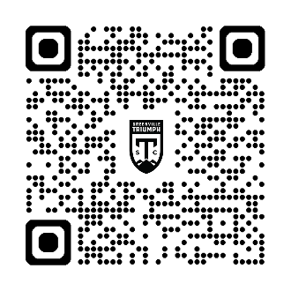

**Halftime Parade:**

* We encourage you to wear your school T-Shirts or shirts that represent your school colors to promote school spirit!
* On the day of the match, we will be holding a celebratory parade at halftime for the students, as well as the teachers.
* Please follow the Read to Score directional signage and meet Triumph representatives at the 30th minute of the first half to participate in the parade.

**Stadium Policies:** Scan the QR Code below to review our clear bag policy, parking information, and items prohibited from the stadium:

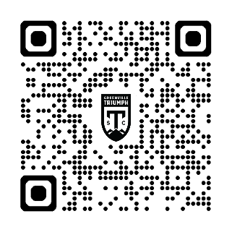

<https://www.greenvilletriumph.com/match-day-information/>

Thank you for your participation in the 2025 Read to Score Program! We look forward to seeing you at the match on Saturday, October 18th at 7:00 PM!

If you have any questions pertaining to the program, contact James Kalinowski at [jkalinowski@greenvilletriumph.com](mailto:jkalinowski@greenvilletriumph.com), by phone at 864-666-0077.